**Document Analysis System: AI Tech Stack Report**

**Executive Summary**

This report provides a detailed analysis of the Document Analysis System (DAS) that we have successfully implemented. The system is designed to process, analyze, and visualize financial reports, specifically SEC filings like 10-K reports, using modern artificial intelligence and data processing techniques. Our implementation has successfully integrated natural language processing, database technologies, and modern web development frameworks to create a cohesive and functional tech stack capable of extracting valuable insights from complex financial documents.

**Architecture Overview**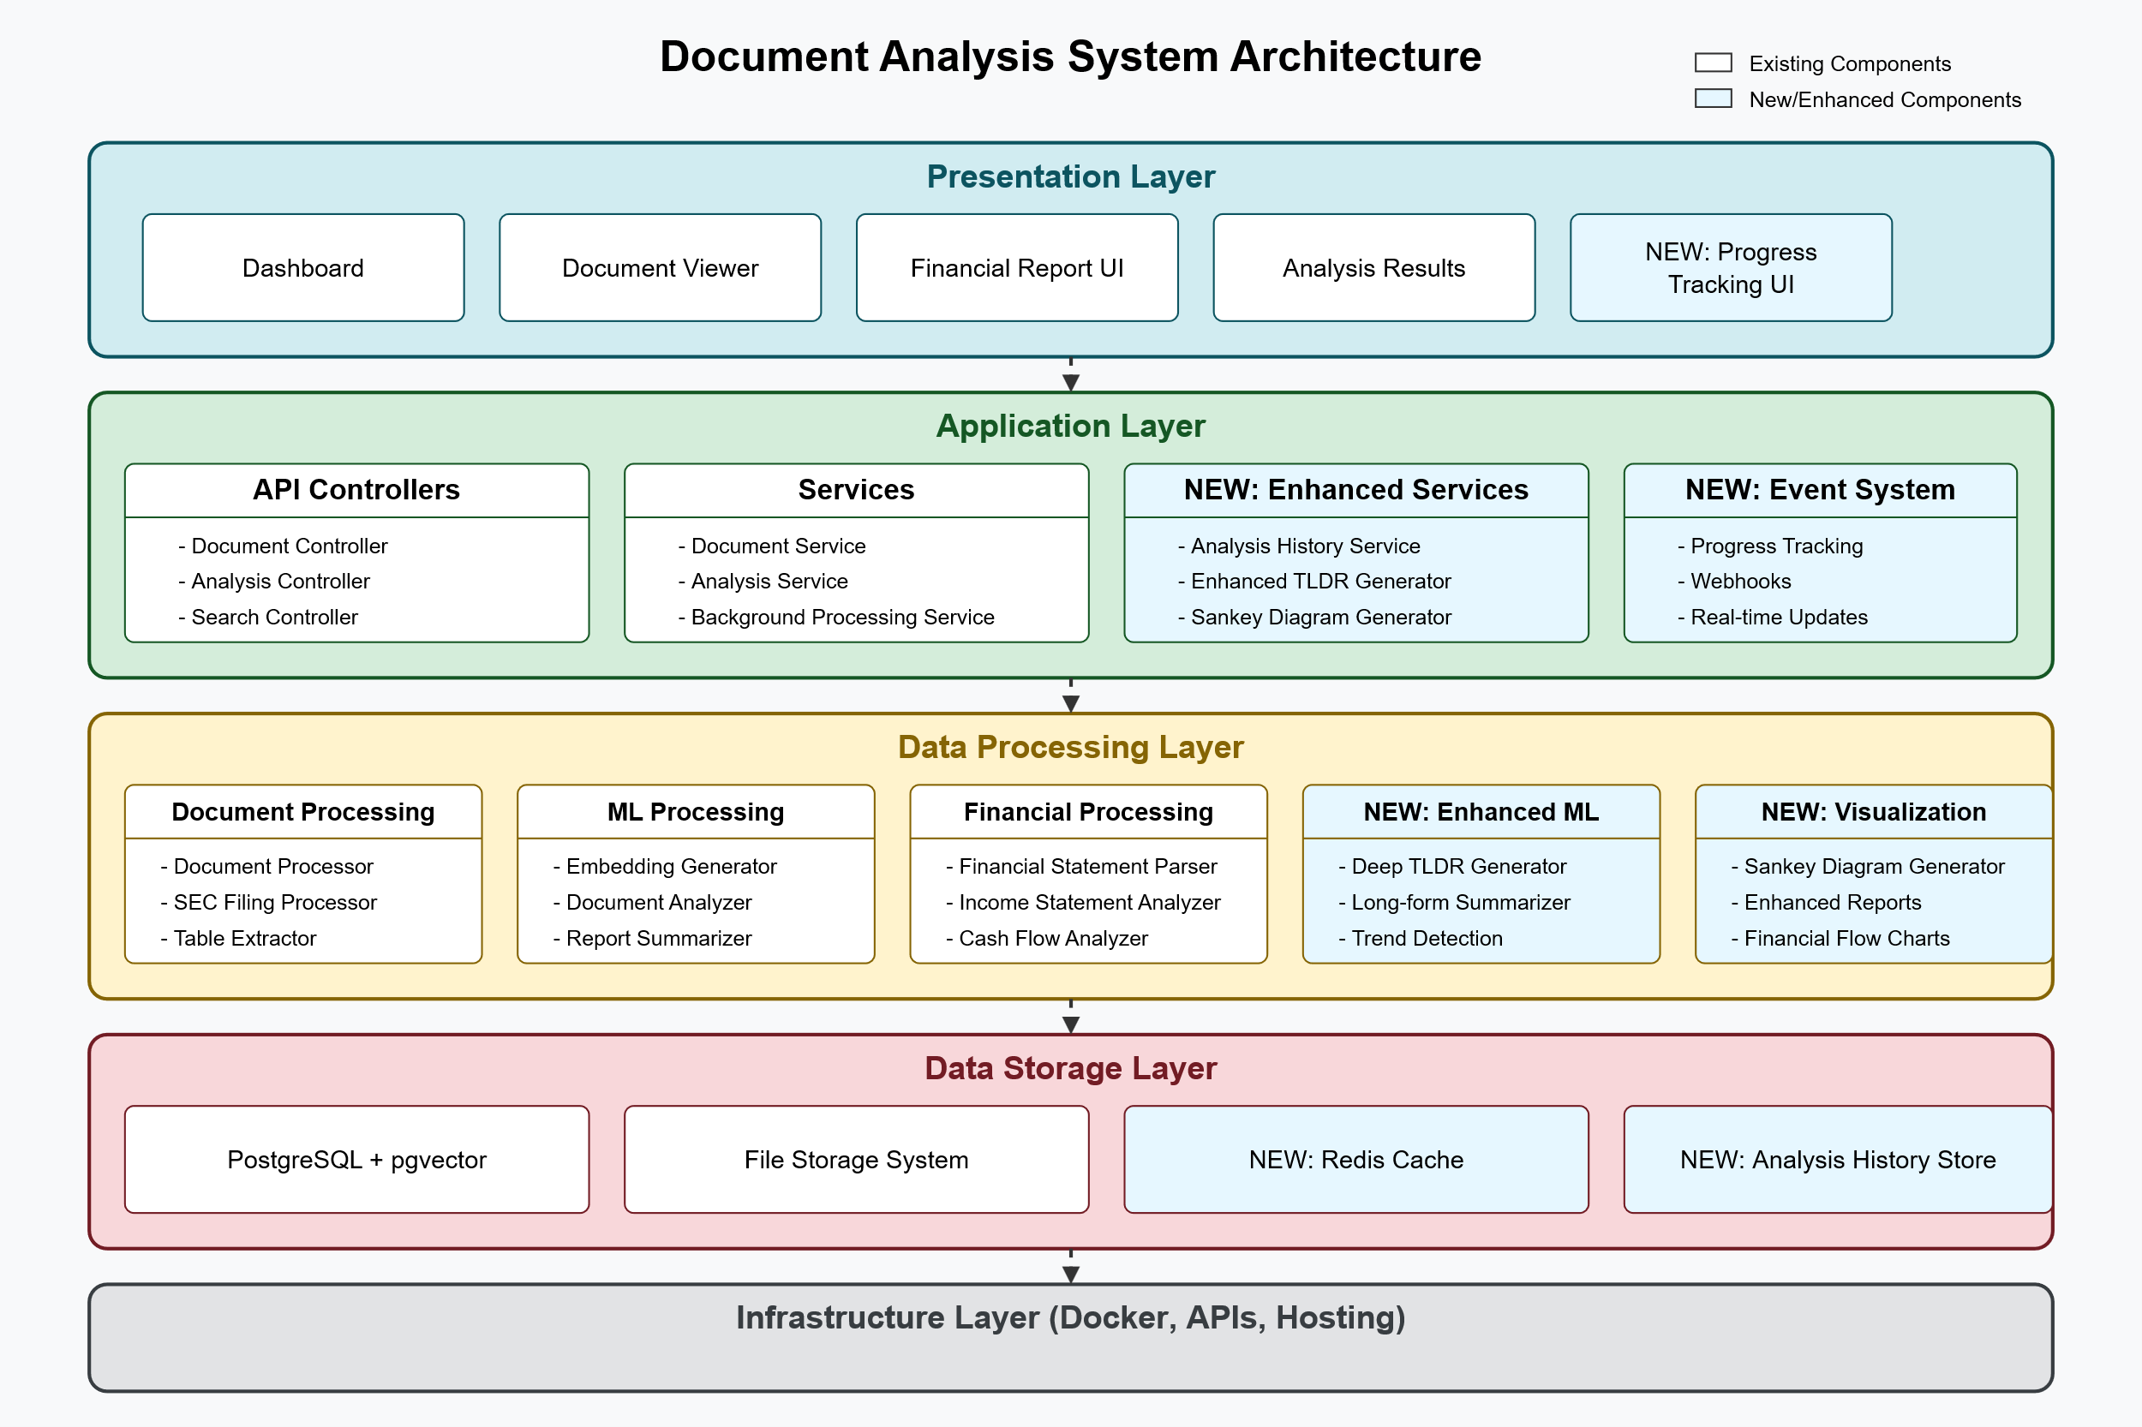

**Current Implementation vs. Original Plan**

**Current Implementation:**

* **Application Layer**: React frontend with D3.js visualizations, FastAPI backend
* **Data Layer**: PostgreSQL with pgvector extension for vector embeddings
* **Machine Learning Layer**: LangChain for document processing, Hugging Face Transformers for text analysis
* **Infrastructure Layer**: Local development environment with Docker for containerization

**Original Plan:**

* **Application Layer**: React + D3.js + FastAPI backend (implemented as planned)
* **Data Layer**: PostgreSQL with pgvector + Apache Kafka (Kafka was not implemented)
* **Machine Learning Layer**: LangChain + Hugging Face Transformers (implemented as planned)
* **Infrastructure Layer**: Kubernetes on GCP + MLflow (simplified to local Docker-based environment)

**Key Differences and Rationale**

1. **Apache Kafka Omission**: We focused on building a functional prototype without the complexity of a message queue system. For our current scale, direct API calls provide sufficient functionality without the overhead of maintaining a Kafka cluster.
2. **Simplified Infrastructure**: Rather than implementing a full Kubernetes deployment on GCP with MLflow for model tracking, we opted for a simpler containerized approach using Docker. This decision accelerated development and allowed us to focus on core functionality rather than infrastructure management.
3. **Enhanced Background Processing**: We implemented a background task system using FastAPI's BackgroundTasks instead of a dedicated message queue. This provides similar asynchronous processing capabilities with less complexity.
4. **Improved Visualization Components**: We developed specialized visualization components like the Sankey diagram for financial flows, which wasn't explicitly mentioned in the original plan but adds significant value to the user experience.

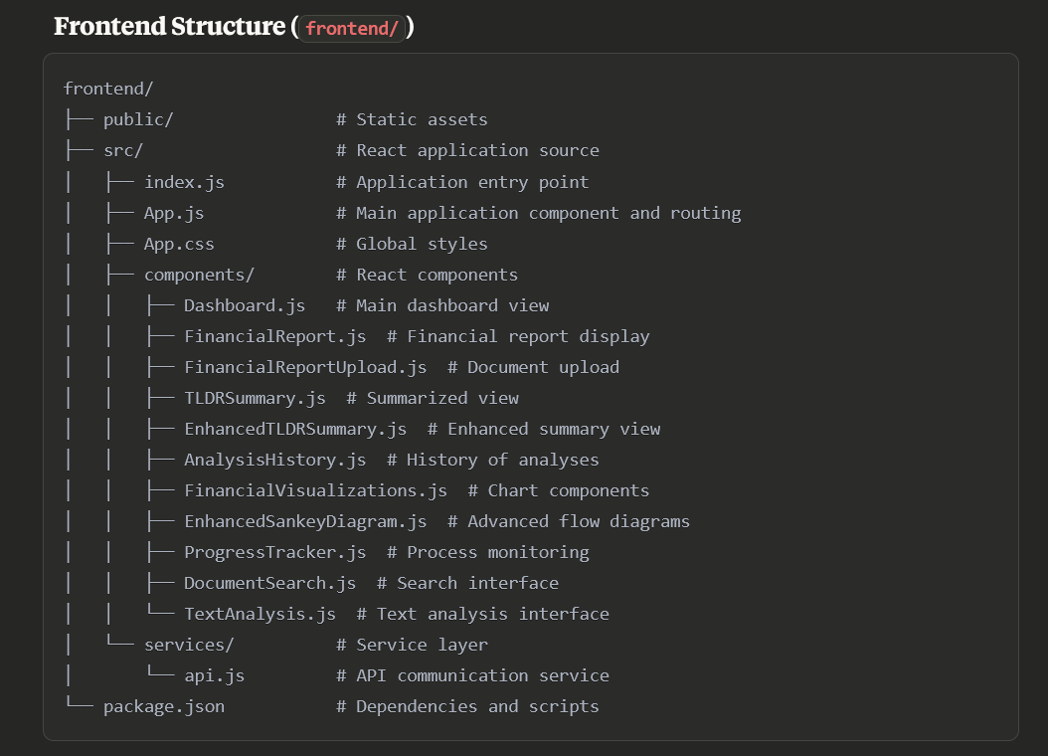

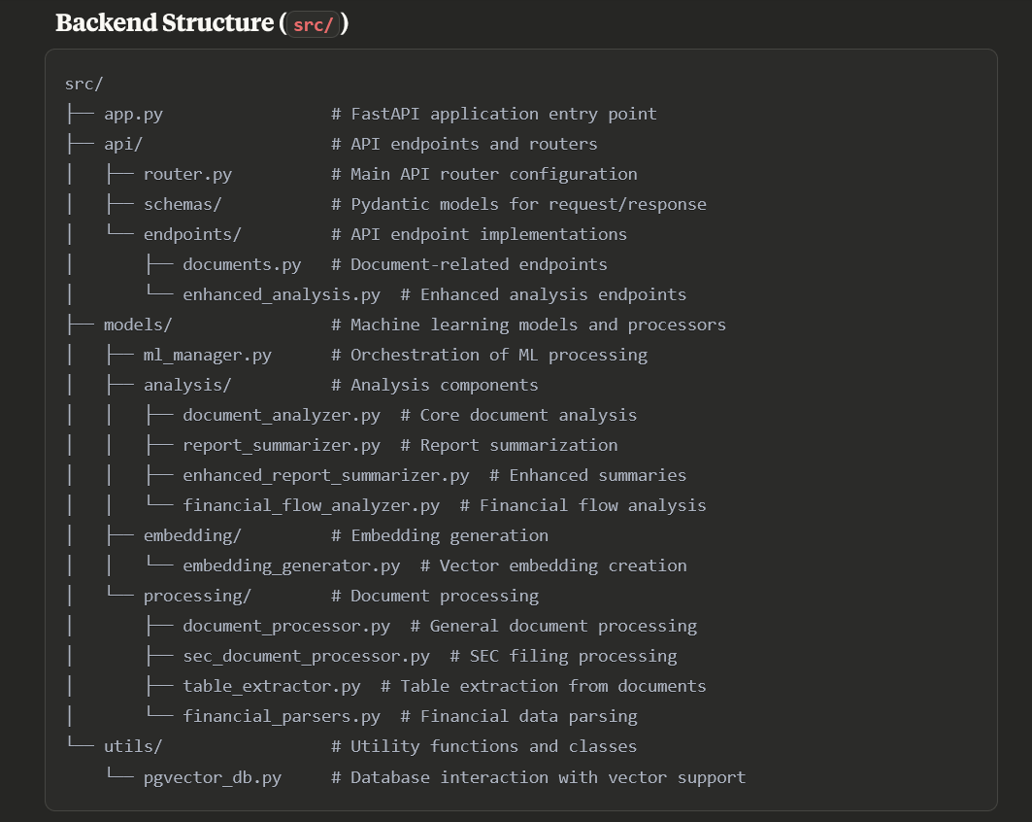

**Detailed Component Analysis**

**Frontend Architecture**

**Core Components**

1. **React Application Structure**
   * **App.js**: Central routing component that directs users to different views including Dashboard, FinancialReport, TLDRSummary, EnhancedTLDRSummary, and AnalysisHistory.
   * **Component-Based Design**: The application follows a modular component structure that enhances maintainability and code reuse.
2. **User Interface Components**
   * **Dashboard**: Main entry point displaying upload, search, and analysis features.
   * **FinancialReportUpload**: Handles document upload with progress tracking.
   * **FinancialReport**: Displays financial data with visualizations organized into tabs.
   * **TLDRSummary/EnhancedTLDRSummary**: Provides condensed and detailed summaries of financial reports.
   * **AnalysisHistory**: Shows previously analyzed documents with access to their results.
3. **Data Visualization Layer**
   * **FinancialVisualizations.js**: Contains chart components including:
     + **IncomeStatementChart**: Bar charts for income statement visualization.
     + **SankeyChart**: Flow diagrams showing financial relationships.
   * **EnhancedSankeyDiagram**: Advanced financial flow visualization showing how money moves through the organization.
   * **D3.js Integration**: All visualizations leverage D3.js for creating interactive, data-driven graphics.
4. **State Management and Data Flow**
   * **API Service Layer**: Centralized in api.js to handle all backend communication.
   * **React Hooks**: Extensive use of useState and useEffect for component state management.
   * **CSS Styling**: Comprehensive styling system that ensures consistent appearance across the application.

**Backend Architecture**

**FastAPI Application Structure**

1. **API Layer**
   * **Router Configuration**: Modular API endpoint management using FastAPI's router system.
   * **Endpoints Structure**:
     + Document upload and processing endpoints
     + Search functionality
     + Document analysis endpoints
     + Financial data endpoints (summary, TLDR, financial flow)
     + Status tracking and history endpoints
2. **Data Processing Pipeline**
   * **ML Manager**: Central orchestrator that coordinates various processing steps.
   * **Document Processors**:
     + General document processor for standard files
     + SEC document processor specifically designed for financial filings
     + Table extractor for processing financial tables in documents
3. **Analysis Components**
   * **Document Analyzer**: Performs sentiment analysis, summarization, and topic extraction.
   * **Report Summarizer**: Creates concise summaries of financial reports.
   * **Enhanced Report Summarizer**: Generates comprehensive summaries with executive insights.
   * **Financial Flow Analyzer**: Extracts and structures financial flow data for visualizations.
4. **Background Processing System**
   * **Task Queue**: Utilizes FastAPI's BackgroundTasks for asynchronous processing.
   * **Status Tracking**: Database-backed progress monitoring for long-running tasks.

**Database Architecture**

1. **PostgreSQL with pgvector**
   * **Vector Storage**: Specialized extension for storing and querying embedding vectors.
   * **Schema Design**: Structured to store documents, chunks, embeddings, and analysis results.
   * **Indexing Strategy**: Optimized for similarity searches and retrieval operations.
2. **Database Schema**
   * **Documents Table**: Stores core document metadata and processing status.
   * **Document_Chunks Table**: Contains segmented text chunks for detailed analysis.
   * **Embeddings Table**: Stores vector representations of text chunks.
   * **Analysis_Results Table**: Persists various types of analysis outputs.
   * **Processing_History Table**: Maintains a record of processing steps for audit purposes.

**Machine Learning Components**

1. **Natural Language Processing Pipeline**
   * **Document Loading**: Specialized loaders for different document formats (PDF, HTML, text).
   * **Text Chunking**: Recursive character text splitter that maintains context boundaries.
   * **Embedding Generation**: Transformer-based models to create vector representations of text.
2. **Analysis Models**
   * **Sentiment Analysis**: Distilled BERT model fine-tuned on sentiment classification.
   * **Summarization**: BART-based model for extractive and abstractive summarization.
   * **Question Answering**: Distilled BERT model for answering specific questions about document content.
3. **Financial Data Extraction**
   * **Table Extraction**: Specialized tools for identifying and parsing tables in documents.
   * **Financial Statement Parser**: Custom logic to interpret and structure financial statements.
   * **Statement Type Classifier**: Identifies the type of financial statement based on content.

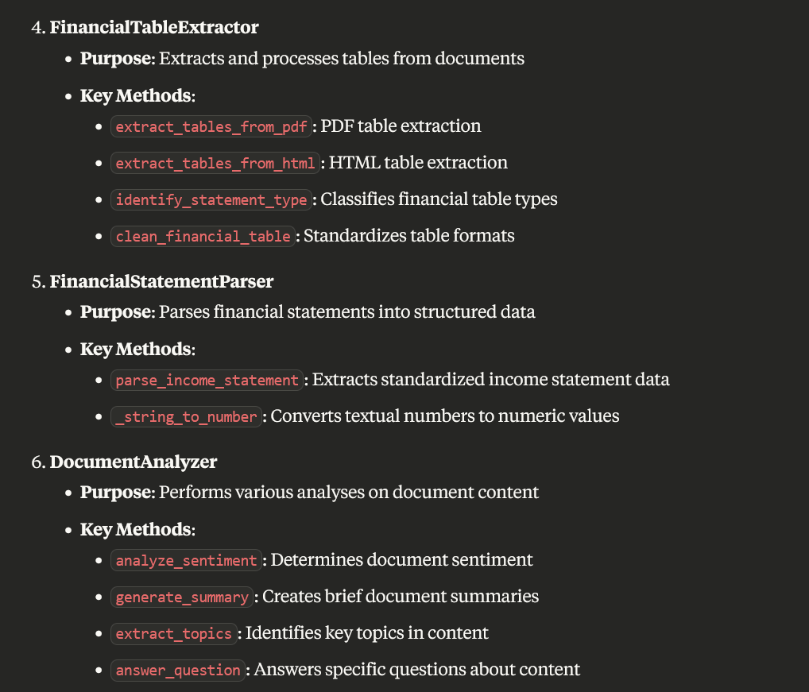

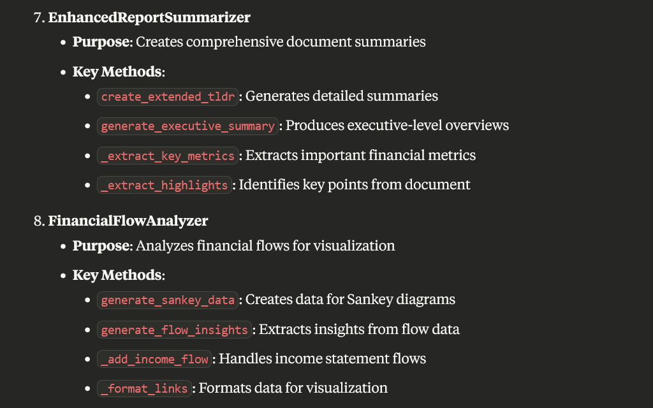

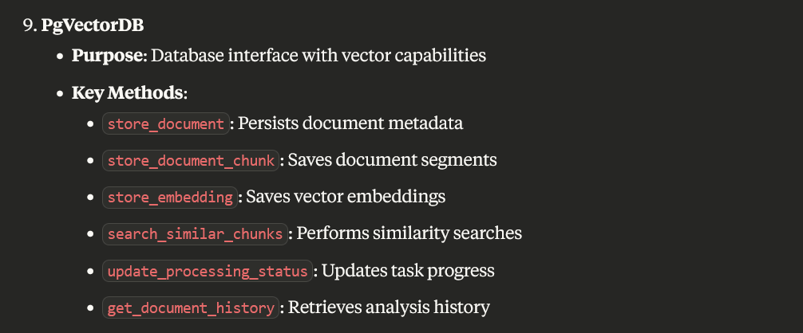

**Key React Components and Their Roles**

1. **FinancialReport**
   * **Purpose**: Main financial data visualization dashboard
   * **Features**: Tab-based navigation, financial metrics, interactive visualizations
2. **FinancialReportUpload**
   * **Purpose**: Document upload interface
   * **Features**: File selection, upload progress, success/error feedback
3. **TLDRSummary/EnhancedTLDRSummary**
   * **Purpose**: Document summary viewing
   * **Features**: Executive summary, section-specific summaries, key highlights
4. **AnalysisHistory**
   * **Purpose**: Historical record of analyses
   * **Features**: List view, document metadata, links to detailed views
5. **IncomeStatementChart**
   * **Purpose**: Visualize income statement data
   * **Features**: Bar chart showing revenue, expenses, profits
6. **EnhancedSankeyDiagram**
   * **Purpose**: Visualize financial flows
   * **Features**: Interactive flow diagram showing money movement
7. **ProgressTracker**
   * **Purpose**: Track document processing progress
   * **Features**: Progress bar, status messages, error handling

**Challenges and Solutions**

**1. Background Processing Complexity**

**Challenge**: Implementing reliable background processing for large documents without a dedicated message queue system like Kafka.

**Solution**: We leveraged FastAPI's BackgroundTasks functionality combined with database-backed status tracking. This provided a simpler but effective approach to asynchronous processing without the operational complexity of Kafka.

**2. Financial Table Extraction**

**Challenge**: Extracting structured data from financial tables in PDFs proved difficult due to varying formats and layouts.

**Solution**: We implemented a multi-stage approach using table extraction libraries with fallback mechanisms. We added table type identification and cleaning steps to standardize the extracted data before parsing.

**3. Vector Database Integration**

**Challenge**: Integrating pgvector efficiently for similarity searches required careful consideration of embedding dimensions and index types.

**Solution**: We designed a database schema that efficiently stores and indexes embeddings, enabling fast similarity searches while maintaining the relationship with source documents and chunks.

**4. Frontend-Backend Integration**

**Challenge**: Coordinating the frontend and backend for features like progress tracking and asynchronous processing required careful API design.

**Solution**: We developed a consistent API response format and polling mechanism for status updates, allowing the frontend to display real-time progress information for long-running tasks.  
  
**Areas for Future Improvement**

**1. Infrastructure Enhancements**

* **Containerization**: Complete Docker containerization for all components
* **Cloud Deployment**: Implement Kubernetes deployment on cloud platforms
* **Scalability**: Add horizontal scaling for the document processing pipeline

**2. Machine Learning Improvements**

* **Fine-tuned Models**: Train domain-specific models for improved financial text understanding
* **Multi-language Support**: Add capabilities for non-English financial documents
* **Model Versioning**: Implement MLflow for model tracking and versioning

**3. Feature Enhancements**

* **Document Comparison**: Add capabilities to compare multiple financial reports
* **Trend Analysis**: Implement time-series analysis for financial metrics
* **Anomaly Detection**: Add ML-based anomaly detection for unusual financial patterns
* **User Authentication**: Implement user accounts and access controls

**4. Data Pipeline Extensions**

* **Message Queue Integration**: Add Apache Kafka for more robust async processing
* **Data Streaming**: Implement real-time data processing pipelines
* **Additional Data Sources**: Integrate market data and news sources

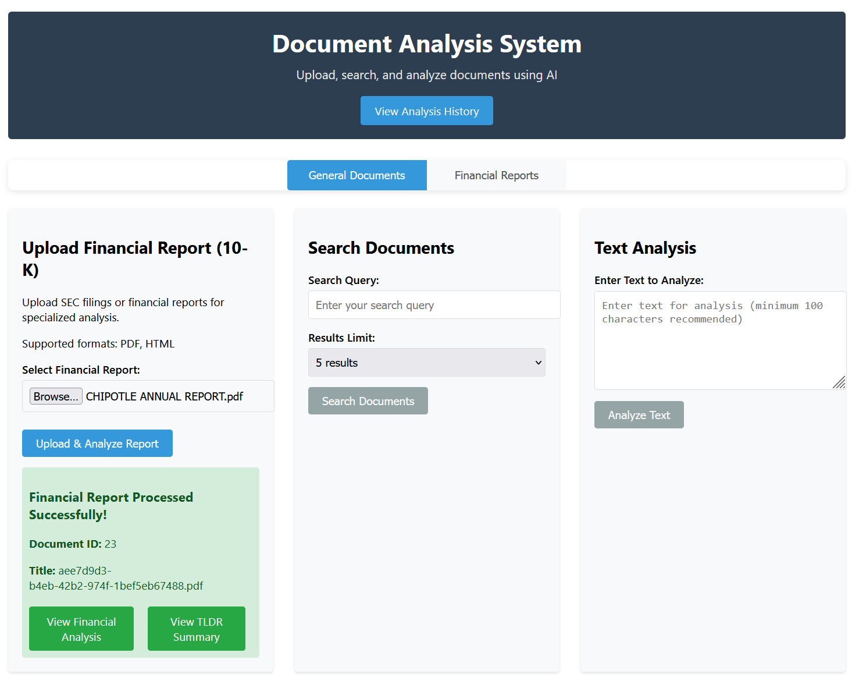

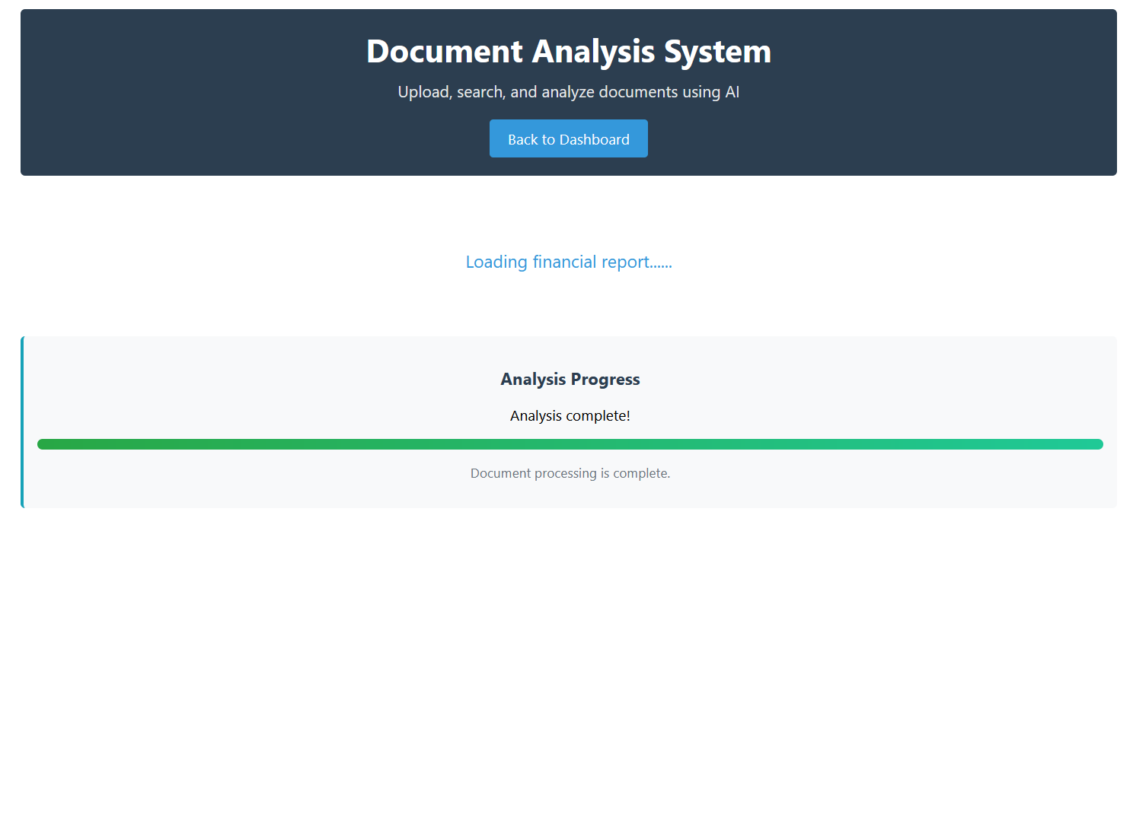

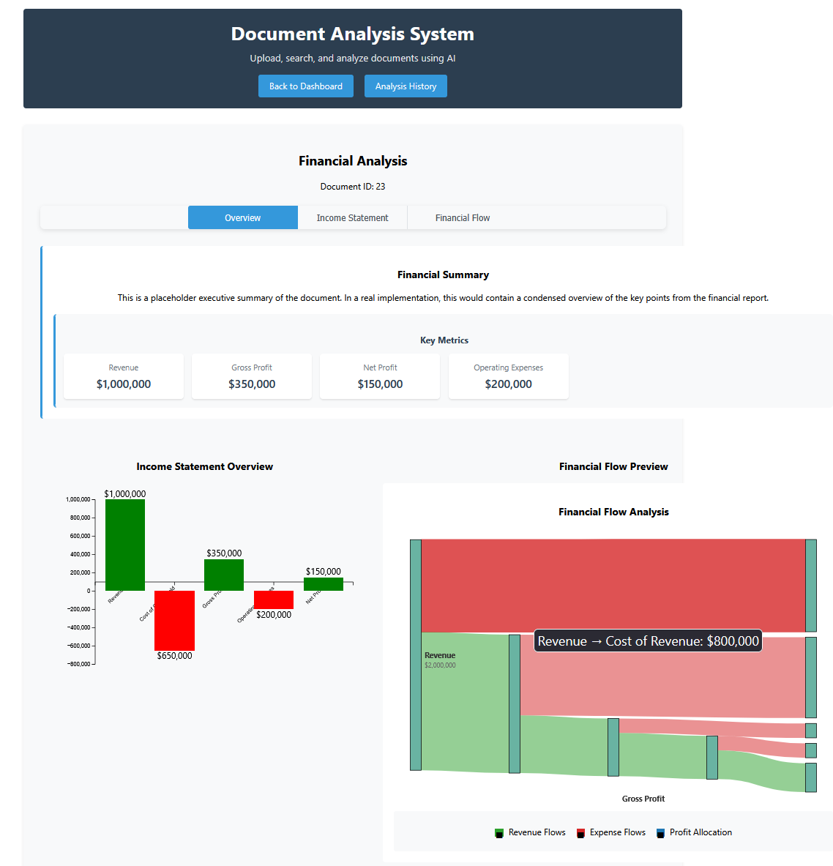_per



